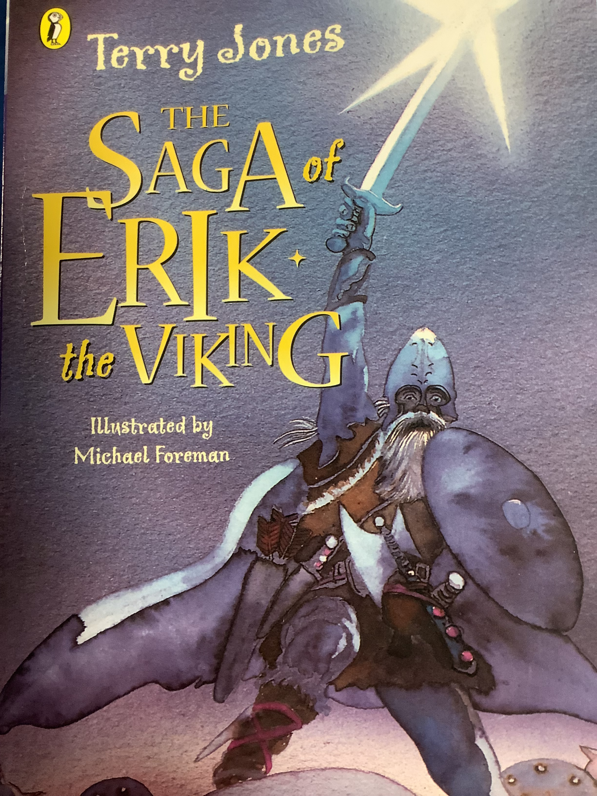
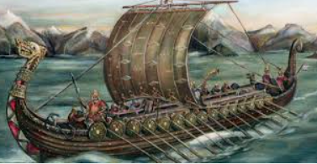
English

In English, we will be studying The Saga of
Erik the Viking and writing our own legends.

We will continue to develop our love of
reading and our comprehension skills
through shared reading and guided
discussions.
Term 3
Courage: How do we decide when it’s right to be brave or fight for something?

History
In History, we will be building on our knowledge of Anglo-Saxons and the seven kingdoms and linking this to the invasion of the Vikings, settling, farming and daily life. Finally we will be linking this to the Danelaw and discussing agreements and peace treaties.
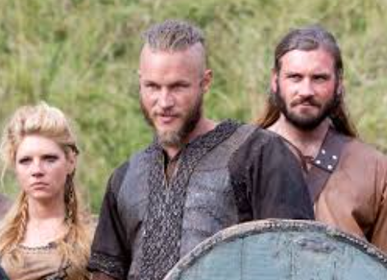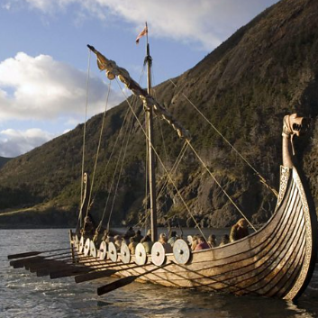

Maths
In maths , we will be focusing , multiplication and division as well as length and perimeter.

PSHE
- We will be discussing motivation in challenging situations, persevering,
and positive attitudes.

- We will also be discussing our goals and helping each other to achieve them.
RE
Is forgiveness always possible for Christians?
We will revisiting the Easter story with a focus on the teaching of Jesus about forgiveness (7x70 times) and the people that Jesus forgave (Peter and the people who crucified him and were crucified with him)

Science
- This term we will learn about electricity.
Children will be able to construct circuits with wires, cells and bulbs.

- Children will be able to draw simple diagrams and identify why some circuits are complete or not.

PE
For our indoor session we will be developing our Gymnastic skills. We will be continuing our work on shapes, balances and rolls.

For our outdoor PE session, we will be developing netball skills in order to play a simple game involving team positions and team tactics.

Spanish
- We will be studying the 4 seasons, Autumn, Winter, Summer, Spring in Spanish.

IT
In IT, we will be using Logo’s ‘Turtle Academy’ to code and programme the turtle to move and perform actions.

We will be exploring a range of different codes to create a colourful car.

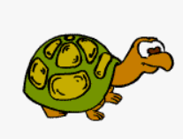

Music

- Preludes: Recorder work with additional instruments.
- Sing up: We will be learning the Doot Doot song.

DT
This term we will be evaluating
electrical systems to design and build a product with an electrical component.

