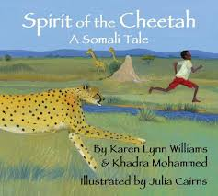
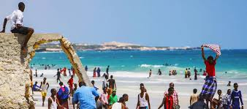
o
PSHE
Relationships. In this unit we will be asking: -How do I manage difficult feelings like jealousy or losing someone I love?
Children will recognise how people are feeling when they miss a special person or animal.
Children will learn to give ways that might help them manage their feelings when missing a special person or animal.

Term 5
Culture: How do families and communities in Somalia show strength and hope?
English
In English, reading and writing, we will be writing traditional tales and newspaper reports inspired by Spirit of the Cheetah. In reading we will be studying Fastest boy in the World.


Science
In science. This term, we will learn:
How sounds are made – exploring vibrations and how they travel through different materials.
Pitch and volume – understanding how the size, shape, and tension of objects change the sound.
Distance and sound – noticing that sounds get quieter the further away they are
Maths
Decimals Money Time
By the end of year 4 children need to read analogue clocks to the nearest 5 minutes and nearest 1 minute. They should also be able to convert digital 12 hour clocks to 24 hour times.
COMPUTING
Children will develop their understanding of how digital images can be changed and edited, and how they can then be resaved and reused. They will consider the impact that editing images can have, and evaluate the effectiveness of their choices.
GEOGRAPHY
In this unit, children will compare Egypt and Somalia using maps, photographs, and climate data. They will explore similarities and differences in land use, settlements, and environments, and learn how climate affects how people live in each country. Children will use comparative language to describe features, such as hotter, drier, or more coastal.

RE
What is the best way for a Muslim to lead a good life?
In this unit, children will learn how Muslims try to lead a good life by following their faith. They will explore key practices like prayer, charity, and kindness, and understand how these help Muslims make good choices and care for others. Children will also reflect on how values such as honesty, respect, and generosity guide everyday actions.

MUSIC
Childre will listen to and compare extracts of music based on the pentatonic scale and will track the pitch shape of a melody showing where it goes up and down. In addition to preludes music sessions.

SPANISH

By the end of this unit, children will be able to present themselves in Spanish, both speaking and writing. They will ask and answer questions, use growing vocabulary, and begin to create their own sentences about personal details such as name, age, where they live, and nationality.

ART
In this unit, Children will use iPads to take and edit photographs that capture hope and courage in their peers or community. They will learn technical skills like composition, focal points, and lighting, while exploring how photography can tell meaningful stories.
PE
In indoor PE, we will be looking at traditional Somalian music and dances and performing in groups
For out door PE, children will give and follow instructions, share ideas, and work together to solve problems. They will use map symbols and keys, and evaluate their teamwork to improve

