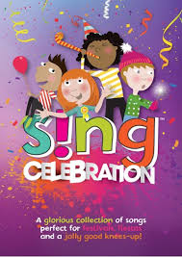

ICT-COMPUTING
Develop the use of count-controlled loops in a different programming environment.
Use a forever loop or count-controlled loop to modify a game.
Develop a design that includes two or more loops running at the same time.
Modify an infinite loop in a given program.
Judge the accuracy of information found online.
Understand how to manage online information safely and effectively.

Science
Understand herbivores, carnivores and omnivores.
Learn the main types of teeth.
Understand the layers of a tooth.
Plan an experiment.
Explore the digestive system.
Understand the process of digestion.
Evaluate the results of an experiment
English
In English, reading and writing, we will be reading traditional stories inspired by music, writing detailed explanation texts and writing free verse poetry.
-We will be reading a fantastic text called Once Upon a Tune by James Mayhew. Each traditional story is inspired from music from around the world.
-In writing, children will increase their knowledge and understanding of scientific concepts by writing detailed explanations on ‘How we hear’ building on the knowledge gained in Science last term.
-We will also be reading a range of poems and writing our own free verse poem based on ‘The Magic Box’ by Kit Wright.


Celebration: How does music help people connect to their cultural heritage?

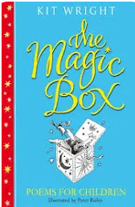
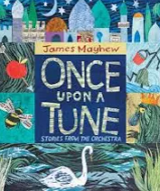

DT
Explore traditional Somali foods and ingredients.
Understand how Somali meals contribute to a
balanced diet.
Investigate Somali flavours and ingredients.
Plan a Somali-inspired meal.
Prepare ingredients safely and hygienically.
Use safe food preparation techniques.
GEOGRAPHY
Use atlases and digital maps to locate continents, oceans and key countries.
Explain how the Equator and hemispheres divide the Earth.
Identify latitude and longitude and explain the global position of countries.
Explain how geography influences music and celebrations.
Describe how music travels from one place to another around the world.
Use a key and map symbols.

PE-Athletics + Tennis
Demonstrate how and when to speed up and slow down when running.
Link hopping and jumping actions with control.
Jump for distance and height, showing balance and control.
Throw with accuracy and power towards a target area.
Demonstrate good balance when performing fundamental movement skills.
Show balance when changing direction at speed and combining skills.
Begin to coordinate the body effectively when moving at speed in response to a task.
Receive a ball using different body parts while under pressure from an opponent.
Strike a ball using a variety of techniques with increasing accuracy and control.
Change direction effectively to lose an opponent.
Create and use space successfully in game situations.
Use simple tactics to help the team score.

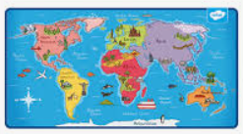




SPANISH-Mi Familia
Present family members in Spanish (names, relations, ages).
Use the possessive adjective “my” with family vocabulary.
Ask and answer “¿Tienes hermanos?” (Do you have siblings?).
Introduce someone using “se llama” and use 3rd person verbs.
PSHE
Understand inherited characteristics from parents.
Identify reproductive body parts.
Understand parenting responsibilities and joys.
Know about puberty and menstruation.
Understand and manage change. Accept changes outside my control.
Look forward to new class changes

RE
Understand consequences of actions for self and others.
Know Sanatani beliefs (Karma, Atman, Moksha).
Understand how Sanatanis live a good life.
Know beliefs about doing good for society.
Understand ways to lead a good life.
Recognise how actions can shape the future

MUSIC
Children In addition to preludes music sessions will be singing ’Favourite Song.’

